**Web Designing**

**MODULE: 6 (Bootstrap Basic & Advance)**

**Q1. What are the advantages of Bootstrap?**

**A1.** Bootstrap is a robust and widely used front-end framework that streamlines the web development process. Bootstrap provides a collection of tools, styles, and components to streamline the process of web development.

**Advantages of Bootstrap:**

* **Speedy Development:** Bootstrap’s ready-made components accelerate development, enabling faster project completion.
* **Responsive by Design:** The built-in grid system ensures websites adapt seamlessly to diverse screen sizes and devices.
* **Consistent UI Elements:** Bootstrap maintains a uniform look and feel across various elements ensuring a cohesive user experience.
* **Cross-Browser Compatibility:** Bootstrap handles browser differences, minimizing the need for extensive testing and ensuring a consistent user experience.
* **Flexible Customization:** Customizable themes and variables provide flexibility to match specific project requirements and branding.
* **Community Support:** Being open-source, Bootstrap benefits from a robust community, offering resources, documentation, and third-party plugins.

**Q2. What is a Bootstrap Container, and how does it work?**

**A2.** Containers are the most basic layout element in Bootstrap and are required when using our default grid system. Containers are used to contain, pad, and center the content within them. Containers are very essential and basic building blocks of Bootstrap that wrap a page’s content.

Bootstrap has the default class or predefined class in the ***“.container”*** & ***“.container-fluid”*** classes for layout.

There are three types of container classes available in Bootstrap:

1. **Default-Container (container)**

It provides a responsive fixed-width container.

**Syntax:**

<div class=”container”>

<!-- Content -->

</div>

1. **Responsive-Container (along with sm, md, lg, xl, xxl)**

Responsive in nature. Responsive containers allow you to specify a class that is wide until the specified breakpoint is reached, after which we apply max widths for each of the higher breakpoints.

**Syntax:**

<div class=”container-sm”>Wide for small breakpoint</div>

<div class=”container-md”>Wide for medium breakpoint</div>

<div class=”container-lg”>Wide for large breakpoint</div>

<div class=”container-xl”>Wide for extra large breakpoint</div>

<div class=”container-xxl”>Wide for extra large breakpoint</div>

1. **Fluid-Container (container-fluid)**

Used for a full-width container, spanning the entire width of the viewport.

**Syntax:**

<div class=”fluid-container”>

<!-- Content -->

</div>

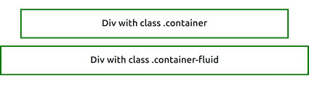

**Q3. What are the default Bootstrap text settings?**

**A3.** Bootstrap uses a default font-size of 16px, and its line-height is 1.5.

The default font-family is “Helvetica Neue”, Helvetica, Arial, and sans-serif. In addition, all <p> elements have margin-top: 0 and margin-bottom: 1rem (16px by default).

**Q4. What do you know about the Bootstrap Grid System?**

**A4.** Bootstrap’s grid system allows up to 12 columns across the page. Bootstrap’s grid system is responsive, and the columns will re-arrange depending on the screen size.

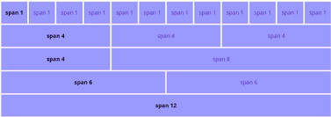

The Bootstrap grid system has 4 classes:

* **xs**  (for phones - screens less than 768px wide)
* **sm** (for tablets - screens equal to or greater than 768px wide)
* **md** (for small laptops - screens equal to or greater than 992px wide)
* **lg** (for laptops & desktops - screens equal to or greater than 1200px wide)

**Q5. What is the difference between Bootstrap 4 and Bootstrap 5?**

**A5.**

|  |  |
| --- | --- |
| **BOOTSTRAP 4** | **BOOTSTRAP 5** |
| It has 5 tiers (xs, sm, md, lg, xl). | It has 6 tiers (xs, sm, md, lg, xl, xxl). |
| It has limited colors. | Extra colors are added, and there are various shades available to choose from. |
| It has jQuery and all related plugins. | jQuery is removed and switched to vanilla JS with some working plugins. |
| Bootstrap 4 supports both Internet Explorer 10 & 11. | Bootstrap 5 doesn’t support Internet Explorer 10 & 11. |
| Radio buttons and checkboxes have different looks in different OS and browsers. The form uses whatever default browsers provide. | The look of the form elements will not change, on different OS or browsers. The forms can be customized and form controls can be added, they would not depend on browsers. |
| We cannot modify utilities in Bootstrap 4. | Bootstrap 5 gave freedom to modify and also create our utility. |
| Columns can be positioned relative. | Columns cannot be positioned relative. |
| Bootstrap 4 doesn’t have its own SVG icons. | Bootstrap 5 has its own SVG icons. |
| It supports Jumbotron. | It doesn’t support Jumbotron. |
| The card deck is used to create a set of cards with equal width and height. | The card deck class is removed in Bootstrap 5. |
| We have an inline-block property and we will get a white dropdown as default for the dropdown-menu-dark class | The inline-block property is removed and we will get a black dropdown as default for the dropdown-menu-dark class. |
| It does not enable RTL(Right To Left) switching. | It enables RTL(Right To Left) switching. |
| It does not support Offcanvas Components. | It supports Offcanvas Components. |

**Q6. What is a Button Group, and what is the class for a basic Button Group?**

**A6.** Button Groups in Bootstrap is a class named “btn-group” which is used to create a series of buttons in groups vertically or horizontally.

Syntax:   
<div class=”btn-group”>

<button type=”button” class=”btn”>Click</button>

</div>

This is the basic syntax of the button group class where each button has its own class of “btn”.

Buttons have a default border-radius on the first and last buttons of the group.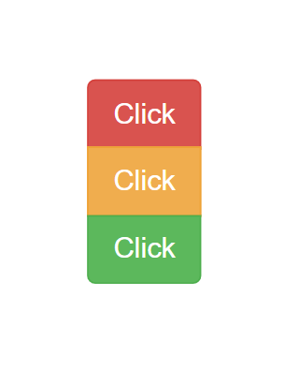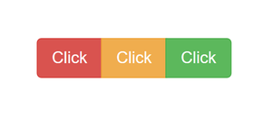

**Q7. How can you use Bootstrap to make thumbnails?**

**A7.** Thumbnails are created to provide a quick preview of images with small images. It is a small image that represents a larger image.

The .img-thumbnail class shapes the image into a thumbnail.

eg: <img src=”demo.jpg” class=”img-thumbnail”>

**Q8. In Bootstrap 4, what is flexbox?**

**A8.** In Bootstrap 4, flexbox is used to control the layout and alignment specifications of Bootstrap 4 components. This box makes it easier to design flexible responsive layout structures without using float or positioning attributes.

**Q9. How can one create an alert in Bootstrap?**

**A9.** Bootstrap provides an easy way to create predefined alert messages.

Alerts are created with the .alert class, followed by one of the four contextual classes .alert-success, .alert-info, .alert-warning, or .alert-danger

eg:

<div class=”alert alert-success”>

Success Demo alert

</div>

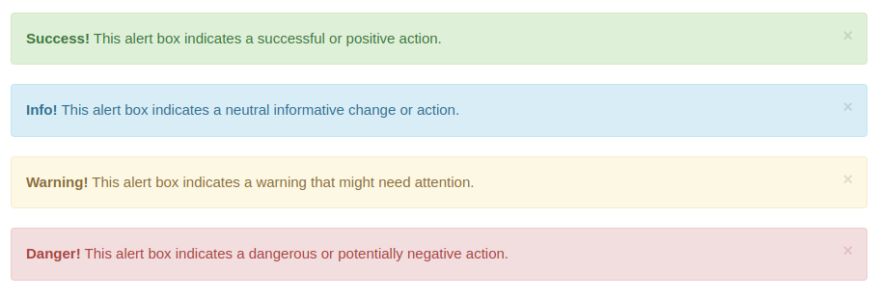

**Q10. What is a bootstrap card and how would you create one?**

**A10.**